

Lincolnshire Land Rover Club





Member’s Magazine
June/July Edition 2026
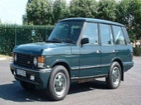
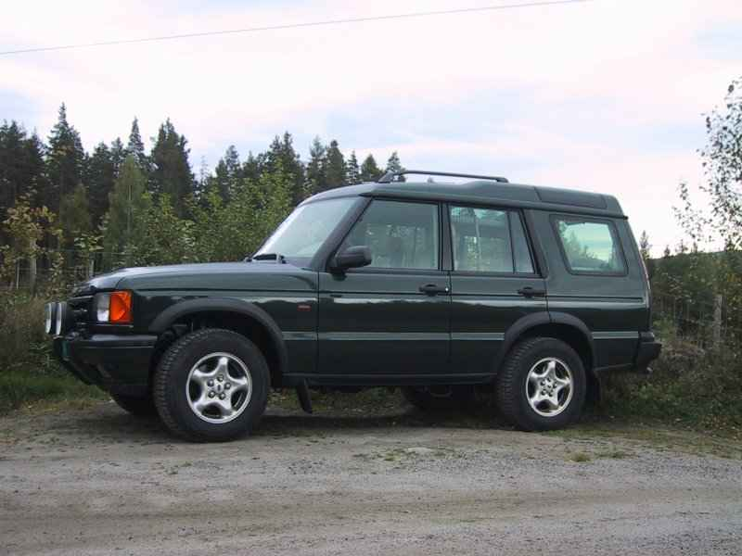
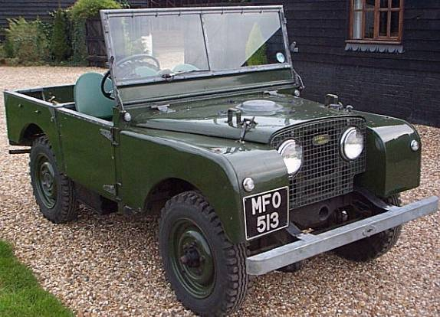
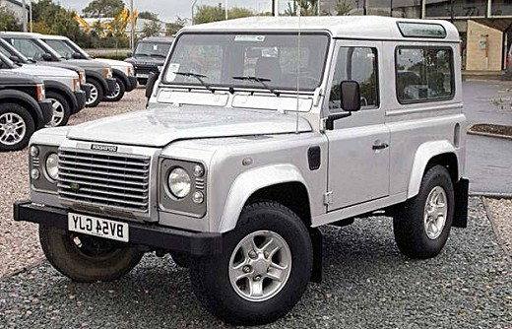
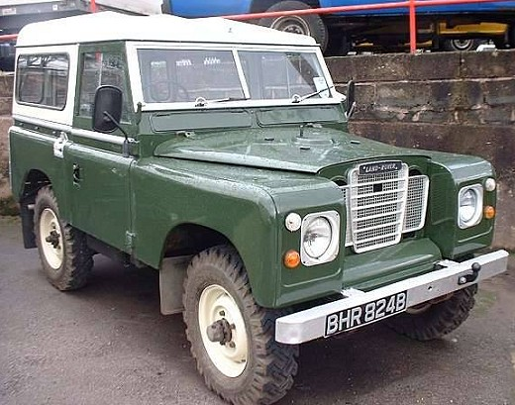
ISSUE No. 408

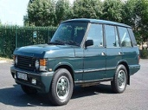


Committee 2026
Chairman | David Summerfield chairman@llrc.co.uk | 11 Woodrush Road, Lincoln, Ln2 4tb | 07969 982727
Vice Chair/Treasurer  EMAMC Delegate | Richard Blackshaw  treasurer@llrc.co.uk | Hillcrest, Carr Road,  Ulceby, DN39 6TX | 01469 540278 07984 769318
Competition Secretary | Jon Sharpe  compsec@llrc.co.uk | 3 Lower Church Road, Skellingthorpe, Lincoln, LN6 5UZ | 01522 402490  07974 234883
Secretary/ALRC  Delegate | Richard Howard secretary@llrc.co.uk | The Grange, Mablethorpe Road, Theddlethorpe, Lincs, LN12 1NN | 07795 821965
Membership Secretary | Andy Balistrari  membership@llrc.co.uk | Picardy, Westoby Lane, Barrow on Humber, North Lincs, DN19 7DJ, | 07984 447802
Comp Safari Officer | Nathan Albery - Pearson  Compsafarisec@llrc.co.uk |  | 07834779028
CCV Officer/Trophy Officer | David Summerfield  ccv@llrc.co.uk | 11 Woodrush Road,  Lincoln LN2 4TB | 07969 982727
RTV Officer | Matt Daubney  rtvofficer@llrc.co.uk | 59 Abbots Road, Scunthorpe, Dn17 1jq | 07791 883320
Magazine Editor/Club Shop | Louise Hanson  shop@llrc.co.uk  editor@llrc.co.uk | 59 Abbots Road, Scunthorpe, Dn17 1JG | 07975 924579
Press and Publicity | Sam Renton | 8 Kent Road, Brookenby, Lincs. LN8 6ET. | 07870 732358
Results/ Chief Marshal | Andy Balistrari  ChiefMarshal@llrc.co.uk  results@llrc.co.uk | Picardy, Westoby Lane, Barrow on Humber, North Lincs, DN19 7DJ, | 07984 447802
Green Lane Officer | Will Howard  greenlanes@llrc.co.uk | The Grange, Mablethorpe Road, Theddlethorpe, Lincs, LN12 1NN | 07484 881616
Committee Member | Matt Howard | The Grange, Mablethorpe Road, Theddlethorpe, Lincs, LN12 1NN | 07807 901754
Committee Member | Charlie Anderson | 22 Huntoft Road,  Sutton on Sea  LN12 2QY | 07957 953276
Chief Scrutineer | Lee Houltby | 88 Matlock Drive, Lincoln LN12 1NN | 07920 486365 01522 821118
Non Committee Post  Child Safeguarding | Simone Birch |  | 07786 443474
Scrutineering Panel

Lee Houltby 07920 486365 /01522 821118 – Lee is also a MSUK & logbook Scrutineer, so make sure you use Lee if you need help with re log booking
Sam Renton 07870 732358
Matt Daubney 07791 883320
Matt Howard 07807 901754

The committee meet on the second Tuesday of the month
You may attend but you should contact the club secretary in advance if you have any issues that you may wish to discuss with the committee.
We are always on the lookout for new members to join the committee, if you think that you could offer your services in the running of your club get into touch with a committee member.

The Press deadline for articles to be included in the Magazine is 5th Sept 2026
All competitive events start at 10 am unless otherwise stated. You must give yourself sufficient time before this time to sign on and get your vehicle scrutineered. You may not be permitted to enter an event after the drivers briefing. For any event next year, please make sure that you renew your 2026 club membership card, 2026 Motorsport UK RS Clubman License. For Comp Safari and CCV’s you will also need your ALRC logbook.

All material is copyright of the Lincolnshire Land Rover Club Ltd. 1986. No material is to be reproduced without the written permission of the editor. Whilst every effort is made to publish member’s material the editor will not print anything he/she considers libellous, untrue or offensive to other persons. Distribution queries should be addressed to either the Membership secretary or the Club Secretary of THE LINCOLNSHIRE LAND ROVER CLUB

Lincolnshire Land Rover Club 2026 Calendar

Please find attached the calendar for 2026, all land is confirmed, and all we need now is some officials. If you can help in anyway, please let an officer or Jon Sharpe know. **CLERKS OF COURSE ARE NEEDED FOR ALL EVENTS – AS A REMINDER - TO BE PART OF THE CHAMPIONSHIP YOU MUST HELP SET AN EVENT* FIRST COME FIRST SERVED.
Month | Day | Venue | Event | Clerks of Course
June | 21 | Hundall | Comp | P&D
July | 5 | South Elkington | RTV | Matt D
July | 11 & 12 | South Elkington | 2 Day CCV
July | 25 | Stainby | Tyro | Richard B
July | 26 | Stainby | Comp and Junior Comp | David S
August | 1 & 2 | Southern | 2 Day CCV | SROC
August | 29 | Eckington | CCV | P&D
August | 30 | Eckington | RTV | P&D
August | 30 | Eckington | Tyro | P&D
August | 30 & 31 | Eckington | Comp | P&D
September | 12& 13 | Wales | Major's Trial | MROC
September | 20 | North Ormsby | Dave Rayson Memorial CCV | Ben K
September | 27 | Newton Lodge | Comp | P&D
October | 4 | North Ormsby | RTV
October | 18 | North Ormsby | Comp
October | 24 & 25 | Wickenby | CCV Night and Day trial
November | 7 | Wickenby | RTV Night trial
November | 15 | Brotherton | CCV | YLROC
November | 28 & 29 | Wickenby | Malachi Comp

LAND APPEAL

We are always on the lookout for land to be able to give members choice for events. If you know of anywhere you think may be suitable, please contact any committee member with the details.
The club now has our own YouTube and TIKTOK CHANNEL – Search for Lincolnshire Land Rover Club to see the latest videos.
Appeal for marshals at events
We need you – we can’t RUN events without you. If you would like to know a little more about marshalling or helping at events, please get in touch with Andy Balistrari on 07984 447802.
Andy is Chief Marshal and will be happy to speak to you and assist you on the day of an event.

Editors Ramblings
Hi all and welcome to the Jun/July edition of the magazine, May saw the success of our ‘new look’ Claxby 3 day weekend, a good weekend was had by all and hat’s off to Matt and Charlie who’s hard work paid off for the changes in the woods for day 2 of the CCV. Although sadly myself and Matt D didn’t make it to the Nationals this year it looks like everyone had a scorcher of a weekend and thank you to David for the write up! Second edition in for me and I am already going rouge with a new feature, inspired by Mrs B....

Louise

Chairman’s Corner
Hi all, it has been a very busy May and June, and still plenty of events to look forward to over July and August with our annual trip to Eckington over the August bank. Hopefully summer is here to stay, although after the sweltering heat at the Nationals some of us were glad to have some cool conditions recently.
We had some big events over May, including Claxby and the ALRC Nationals, where you can see the results and some pictures throughout the magazine.
A massive thank you to everyone that came and supported Claxby, our new landowner Simon was very pleased of how the club ran the event and is more than happy for the club to go back to the site for more events. The new layout worked for all the campers and competitors alike, with a great weekend had by all.
We followed Claxby with the Nationals, where this year was hosted by Midland Rover Owners Club.
As I have visited the site before for the majors 2 day CCV. I knew that anyone going would enjoy the site, with the spectacular views and competition ground.
We had a good representation of the club in competitions and from those who came to camp or travelled down to support the competitors and have a good weekend away with friends. We had entries in all events except the TYRO.
Well done to the trophy winners
Theo Summerfield in the bike trial
Nathan Gibson, Brian Kitchen, Dave Doherty and Chloe Bayliss in the Comp Safari.
Richard Summerfield and Phil Henshaw in the Team Recovery.
For those who didn’t go, you missed out, at present the ALRC has no club or site that has been offered up for 2027, hopefully a resolve happens soon.
We head in to July with events in all disciplines. An RTV, 2 Day CCV both at South Elkington this is followed at the end of the month with a weekend at Stainby with a TYRO and back by popular demand the Junior/Senior Comp Safari. All details in the magazine or on Facebook soon.

To end my post, I have been asked a question to put to our members for any ideas regarding an event to remember the members who have sadly passed away over the last few years. We currently have the Barrie Murdoch and Dave Rayson Memorial CCV’s, with a perpetual trophy for winners of these events of which got donated by their family members.
I would like some ideas from the members of an event that the club could put on to remember our past members collectively. This can be as a competitive event or a social event? If anyone has any ideas in any way, can you let me or a committee member know please.
Thanks David

Club V’S Trophy 2025

So after 2 events, Lincs have taken a lead, leads try and hold on it and take home that trophy!
The events included for 2026 are Stainby RTV & CCV, Claxby CCV & RTV, Stainby Comp, Eckington RTV, CCV and Day Comp, Brotherton CCV and the Malachi Comp. So 10 events, all events are included in both clubs championship, and allow all members of both clubs to be in attendance. Results are taken from the top 3 drivers from each club from the relevant disciplines. So both clubs can be rewarded points. Points will be rewarded from 10 to 5. Ie 1st 10, 2nd 9 3rd 8, 4th 7, 5th 6, 6th 5. The club with the most cumulative points at the end of the year takes home the trophy.

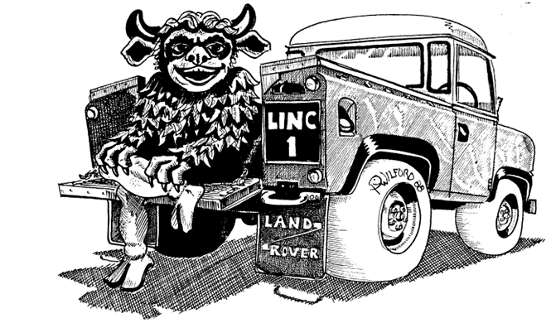



Please check our website, Facebook and YOUTUBE Channel for updates as well as www.llrc.co.uk



RESULTS

Claxby 3 day weekend Results

Kacy and Ash in the Tyro at Claxby

South Thorsby RTV

ALRC NATIONALS 2026

The weather looked promising and having been to the site before, was looking forward to a mini holiday down in North Wales as well.
I was greeted at Rally control by Sam, who had just pulled up in his 90 and looked a bit stiff walking around after a good drive down.
We drove off to find our club pitch, which for this year was the furthest point in the campsite. We will get out steps in this year for the beer tent. We were greeted with the Gibson clan, who were already sun bathing and on the pop. Throughout the afternoon the rest of our members turned up with the rest coming on Friday.
Friday was about scruteenering and the RC cars. With a good mixture of adults and kids taking part. We were represented by the Summerfield’s and the Bayliss’s in this event so was good to go and watch some chilled-out competition.
Saturday came and it was the day of the CCV- the CCV had sold out and was at its 120 capacity, which hasn’t happened in a long time, Linc’s had 7 drivers representing. I was in a group with the Marris’s and Lewis and Dan from P&D, so knew we were going to have a good day together. The sections were excellent and the day ran smoothly with only a few hold ups along the way which is expected after a full capacity turnout.
I believe the rest of the CCV drivers in Linc’s also had a good day. With myself finishing 9th, with the other members who’s finished Phil, Richard and Ben all inside the top 40.
The evening saw the Bike trial, which Theo represented and after some tinkering with his brakes, he came home with one of the best trophies of the weekend, the Welsh dragon teddy trophy. Something special to cherish.
Sunday was the turn of the RTV, where Sam was representing Linc’s by himself. Whilst out walking the 5.2-mile comp course, we bumped into some RTV drivers who said they were enjoying their day and, on our return, Sam concurred and finished the day on 7 points with a Top 20 finish overall
The afternoon was the time for the TEAM RECOVERY- a spectator's sport, a chance to watch the entrants maybe make a fool of themselves in the mud, and yes, we had mud this year. Myself was with Connor form P&D and Richard was with Phil Henshaw. We had 3 different mud holes to tackle with 2 runs. 2 of the 3 holes were drivable or all 3 if your Dave Mercer. It then came down to how fast you could get round the course and get the rope on and off.
I messed up on the 1st run and parked top far away to get the rope on which cost us loads of time, whilst Richard and Phil had a problem driving over the rope and this cost them time on their last run but they finished 3rd and myself and Connor came 5th out of the 9 teams entered. Thanks for everyone who came and watched and cheered us all on.
Monday was the day of the Comp Safari which Staffs and Shrop’s were running. After walking it the day before, it was going to be a day of attrition. Monday was the warmest day with the temperatures, and it was well into the early 30’s and with a 5-mile course of 6 runs, it was going to take it out of the car and driver.
We had 7 entries for the Comp Safari nd the competition was as hot as the weather.
Brian was fighting to retain his title from last year. Chloe and Emily were after the ladies trophy and these rest were after a finish or class trophy.
Unfortunately, Emily and Ben’s day finished with retirement.
The rest of the entries survived the day with Brian taking 1st in class and 3rd overall, Nathan taking 3rd in class, and Chloe taking the Ladies. The team of 3 entered of Brian, Nathan and Dave also took the honours for that.
Overall the weekend was excellent at the Club representing well in all the competitions that were entered, hopefully a solution for next year won’t be too far away.

David

Sth Elkington
2 Day CCV
11th/12th July 2026

Sponsored by MJD COMMERCIALS/GRAYTON LTD
Nearest Postcode – Ln11 0ru, on the A631 near Louth.
Clerks of the course – Looking likely to be a s self set – unless anyone can help
Saturday times *Scrutineering:- from 12*
Drivers Briefing:- 12:45*
First Section 1:00pm
Sunday start time 10am
Entry fee £50
**Please remember to bring your 2026 club membership card, RS Clubmans License and your vehicle log book.
For further information please contact David Summerfield –07969982727 – CCV Officer
Both days are INCLUDED IN THE LINCS CCV CHAMPIONSHIP
If unable to compete on the Saturday a reduced fee of £30 will be applied.
Camping is available from the Friday night, there will be no water or facilities. So bring your own. It’s a great site for a weekend away.
MARSHALS ARE REQUIRED PLEASE – ANY HELP YOU CAN GIVE IS MUCH APPRECIATED.

Junior/Senior Comp Safari at Stainby
- Part of the Lincs and P&D Championship
Postcode - NG33 5QP
///huts.reserve.situated
Kindly sponsored by Nathan Gibson and Ruby Kitchen
CofC - David Summerfield
Pre booking is compulsory, with no entries on the day. There will be a cap on numbers to allow the junior and senior runs to get completed separately throughout the day.
Booking going Live soon

The weekend will also include a TYRO on Saturday 25th July afternoon with a 1 o’clock start time - no booking required
Kindly sponsored by Ryan Gibson
CofC- Richard Blackshaw

Sunday timing- TBC and will be sent out after booking. With running both events, we need to plan the schedule so that the seniors and juniors run at separate times. We aim to start the junior prep at 9am with the first laps from 10am and finish at 4pm

Pricing
£20 TYRO
£40 Junior comp entry
£50 Senior comp entry
£10 Weekend Camping
Please direct any queries to David Summerfield -07969982727
CAMPING IS PERMITTED FROM FRIDAY EVENING - Please bring everything required as there is no water on site and take your rubbish home with you. Toilets on site.
CHL Catering will be there on Sunday

Regulations for the Junior Comp Safari

Eligibility:
- Drivers to be of at least 14 years of age
- Entries may be accepted from drivers who are 14 years of age where they have already finished 1 Junior Competitive Safari.
- Drivers are permitted to continue until 31st December of the year of their 18th birthday
- Minimum height of Junior Driver: 1.35m,
- Driver has finished 3 ASN permitted events or 1 Junior Comp Safari
- Must have an experienced Co-Driver of 3+ Competitive Safaris (inc. Plus) and/or Hill Rally's finished as a Driver or Passenger,
- Passenger must have a Full Valid RTA Licence
- Passenger must be over 21 years of age,
- The CofC to be satisfied the Passenger meets a suitable standard of experience.
Pre Event
- Dedicated separate briefings for Drivers, Navigators & Officials must be sent out in advance. The method of this should be electronic.
- The briefings will follow the Motorsport UK template provided. (Note:~ to be created)
- Timetable of the event to be shared in advance with the competitors.
Pre Competition
- Where at a shared event - Extended Drivers Briefing for Juniors, with only Junior Drivers and their passengers present
- Sighting/Look see lap mandatory (with the Junior Competitor driving). – To be observed to the satisfaction of the CofC or other Senior Officials.
- Sighting/Look see lap to be controlled by an Officials vehicle at front and rear of convoy.
- Tutorial Passenger lap (Where the signed-on passenger drives at approx. 50% of competition speed) to be included in the event schedule prior to first competitive run.
- At the CofC discretion, a second Tutorial Passenger Lap will be permitted approximately halfway through the event to enable further demonstration & education from the Passenger to the Driver. No competition must be taking place whilst this secondary lap is in operation.
- Helmet, FHR & minimum 4-point harness to be warn during sighting/look see lap & passenger lap.
Safety / Technical:
- Event complies with Competitive Safari Technical & Safety requirements
- The Chief Medical Officer or Chief Paramedic being a Doctor or ASN Registered Paramedic
- Chief Scrutineer must be appointed from Motorsport UK Technical Officials
- Driver must demonstrate to the CofC satisfaction they can operate the controls of the vehicle (pedals and steering wheel) during pre-event Scrutineering
- Driver must be able to demonstrate to the CofC satisfaction that they can extract themselves from the vehicle within 10 seconds.
- No other Competition must be active/live at the same time at the same venue whilst the Junior drivers are actively on course.
- Only Junior drivers may be on the course during competition.
- Co-Driver must be able to operate a Circuit Breaker (Kill Switch)
- No Spectators other than those in a designated safe area
- Competition vehicles to be in sight of Marshal posts as much as reasonably possible
- Use of woods/forest or tree-lined tracks should be reduced to a necessary minimum.
- Red Warning Lights to always be switched on
Sporting:
- Maximum average speed: 30mph,
- Maximum course length: 2miles, Where the maximum competition distance exceeds 12 miles.
  - Where it does not exceed 12 miles, the course length is set to the CofC discretion.
- Total Maximum competition distance must not exceed 12 miles, Where the maximum course distance exceeds 2 miles.
  - Where it does not exceed 2 miles, the maximum competition distance is set to the CofC discretion.
- Split & Merge is prohibited
- Course must be laid out to reduce the maximum potential velocity of a vehicle. Consider maximum 'straight line' distance prior to a change of direction.
- First 2 laps to be at 2 minute intervals and only reduced (to a minimum of 1 minute) if the CofC is happy no adverse risk is foreseen. If conditions change for the worse / are wet from the start, recommend keeping the gap for the duration
- Minimum of 30 minutes between completed competitor runs.
- ‘Back to back’ runs are prohibited.
- No Live Recovery
Misc.
  - Motorsport UK to appoint an Observer to be present during the trial
Introducing our new feature... Pips pals

PIPS PALS

If your pooches would like to feature in Pip’s pals and share their land rover adventures, please send in your pics 😊

Gloria and Bella
Bella Zebedee and Charlie

Minutes of llrc committee meeting
12 MAY 2026
1. In attendance
Richard Blackshaw, David Summerfield, Richard Howard, Jon Sharpe, Will Howard, Matt Daubney, Louise Hanson, Sam Renton, Lee Houltby
Apologies
Andy Balistrali, Matt Howard
2. Minutes of previous meeting.
Read by David Summerfield Proposed by Sam Renton seconded Will Howard
3. Matters arising from minutes.
Family member numbers sorted
4. Correspondence
Hemswell hanger meet club invited to attend 23 may 10 -15 cars
Martin Farley proposed an event for all past members to be discussed next time
5. Treasurer’s report
Cash £0
Pay pal/izettle £120
South Thoresby comp £80.05 loss
6. Comp sec report
Next event nationals
Teams ccv 1. Richard / David /Ben 2. Charlie /Chris / Phil
Comp Nathan / Nathan / Dave Ruby / Emily / Cloe
Nom ccv driver David
7. Show News
Newark show want ideas for a display on the flat
8. Press and Publicity
none
9. Scrutineers Report
Digital log books are now live online system running
10.Equipment Officer Report
Trailer at Bens Big thanks to Ben for stakes for Claxby
Motorsport signs need finding
11.Timing Van.
none
12.Membership Secretary Report.
Full 74
Honorary 9
Total 83
13.Trophy officer report
Trophies sorted
14.Health and Safety.
none
15.Safegaurding
Richard has passed dbs checks
Junior comp may require one
16.Sponsorship
none
17.Club shop
none
18. Debriefs
South Thoresby comp hot and dusty good event not well attend
Claxby good weekend Matt and Charlie put in a lot of effort to clear ground for sections this didn’t go unrecognised
Possibly a day event next year
19. A.O.B
None
Meeting closed at 21.15
Next meeting June zoom

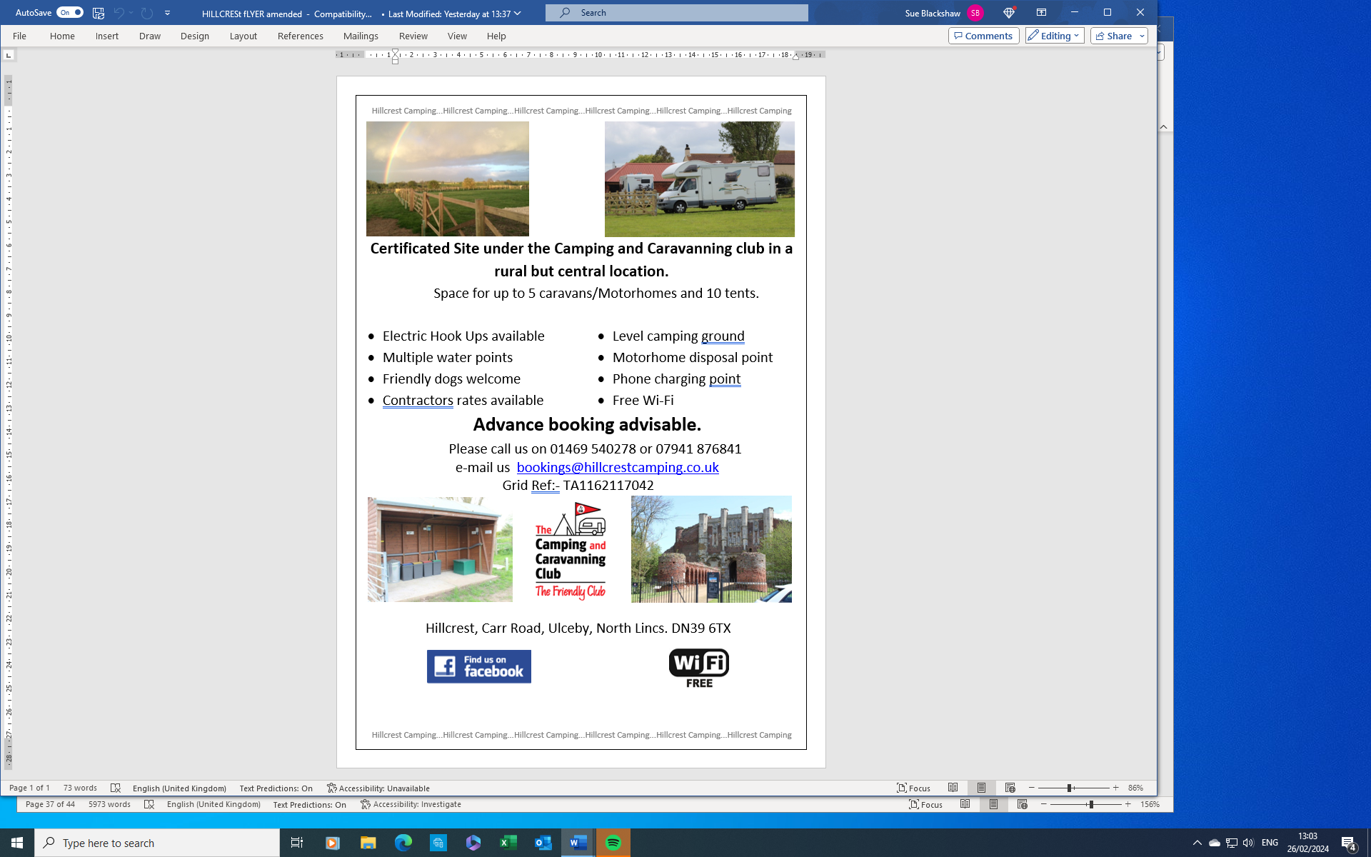

Thank you to our 2026 Sponsors:-

The Ryan Gibson
2026 Tyro Championship

E
Official sponsor of the 2026 CCV Championship



Official sponsor of the 2026 RTV Championship



Sponsor of South Thoresby CCV

Burton Autos
Unit 4
Garden Farm
Thornton
Horncastle
LN9 5JU
Vehicle body and paint shop for cars old and new, motor bikes and anything that’ll fit through the doors including the obscure.
Tel: 07887 576707
Sponsor of Dave Rayson Memorial CCV

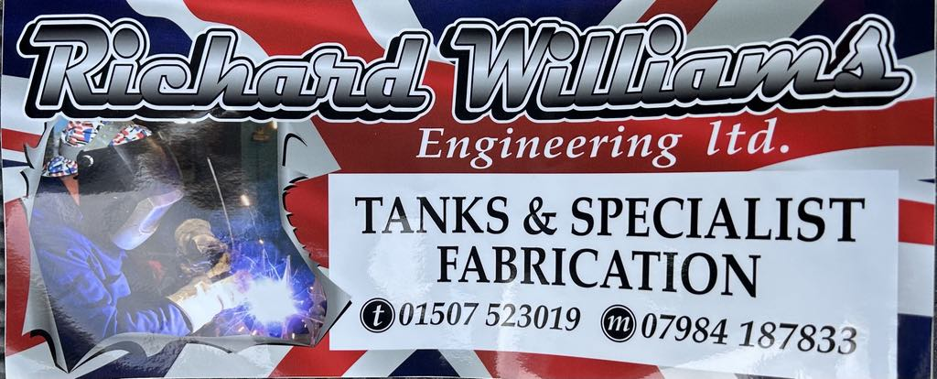
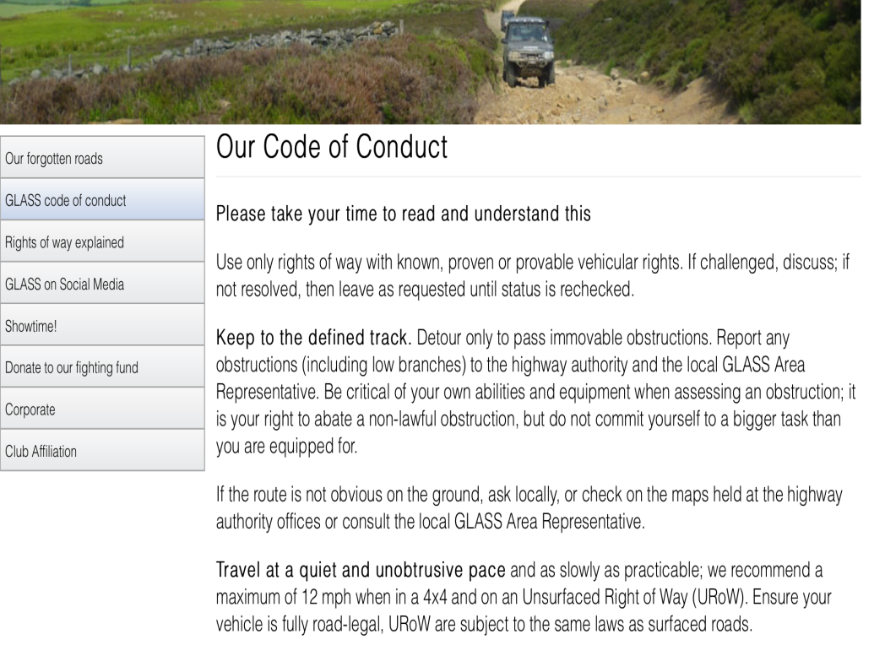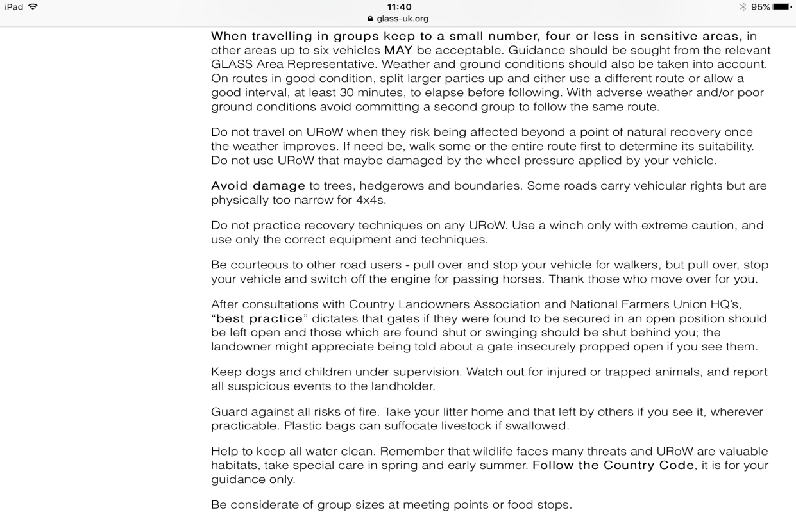



Would you like to sponsor an event in 2026?

As in previous years work is afoot to gain sponsorship for the events but we also want to give you, the club members the opportunity to sponsor an event if you wish.

Here are the basic details:-
The sponsorship on offer is for individual events often alongside the championship sponsor.

What will I get for my money I hear you ask?
- One membership
- Your name on the trophies at each event
- An advert in our bi-monthly magazine (if applicable)
- Frequent mentions on both our Website and Facebook pages where possible.
For individual events the cost is £75 (or £50 for existing Club Members.)

What happens next:-
If you would like to sponsor an event then please take a look at the Provisional Calendar and pick which event(s) you would like to sponsor. These will be allocated on a first come first served basis so if you wish to do this please act quickly. Please either contact myself (David) or Jon Sharpe to stake your claim and we will do the rest.



All traditional roofing undertaken:-
Chimney Repairs Lead work

Guttering Competitive Prices

Please call Tim on 07795 631025



Sponsor of South Elkington 2 Day CCV

ADVERTISING RATES
£120 full page for 1 year, £65 ½ page
Price includes one year membership, Adverts in individual magazines are available to members only at £10 per issue

NOTICE
Could all Competitors remember to use a sheet when working on their vehicles at ANY TIME & at ANY SITE....
Possible exclusion from the event could
occur if this is not heeded to!




